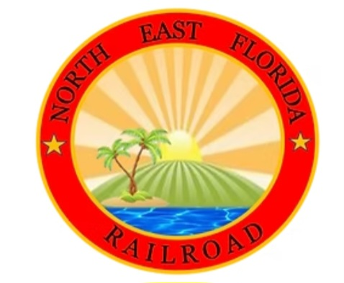
NORTHEAST FLORIDA LIVE STEAMERS & RAILROADERS, INC
516 GRAND LANDINGS PKWY
PALM COAST FL 32164

MEMBERSHIP APPLICATION

DATE: _________________________________________________________
NAME: ________________________________________________________
ADDRESS: ____________________________________________________
CITY: _______________________STATE: ____________________________
ZIP CODE: __________________ PHONE: __________________________
EMAIL ADDRESS: ______________________________________________
ANNUAL DUES (JANUARY 2025) FOR ALL MEMBERS, REGARDLESS OF YOUR ADDRESS IS: $65.00
JUNIOR DUES WITH RESPONSIBLE ADULT: (Adult is $65, child is $35) $100.00
AMOUNT ENCLOSED ____________________
Mail this application along with your Check or Money Order to :
NEFLS now accepts credit cards. Contact Alan to make a payment.
Alan Bredenhorst
C/O Northeast Florida Live Steamers
516 Grand Landings Pkwy
Palm Coast FL 32164
NEFLS is a 501C3 Non-Profit Organization

